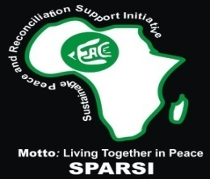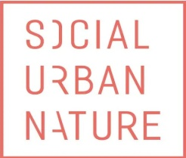
SUSTAINABLE PEACE AND RECONCILIATION SUPPORT INITIATIVE (SPARSI)
IN PARTNERSHIP WITH
SOCIAL URBAN NATURE (S-U-N)
PRESENT EIGHT MONTHS ACTIVITIES REPORT ON
VOICES OF RESILIENCE: SUCCESS STORIES FROM THE TRAUMA HEALING PROJECT
Project: Trauma Healing and Peace Building: A Journey Towards Resilience
Implementing Partner: Sustainable Peace and Reconciliation Support Initiative (SPARSI)
Funding Partner: Social Urban Nature (SUN)
Implementation Period: May - December 2025
Target Areas: Chibok, Gwoza, Damboa, Askira, and Uba LGAs, Borno State
Report Date: December 19, 2025

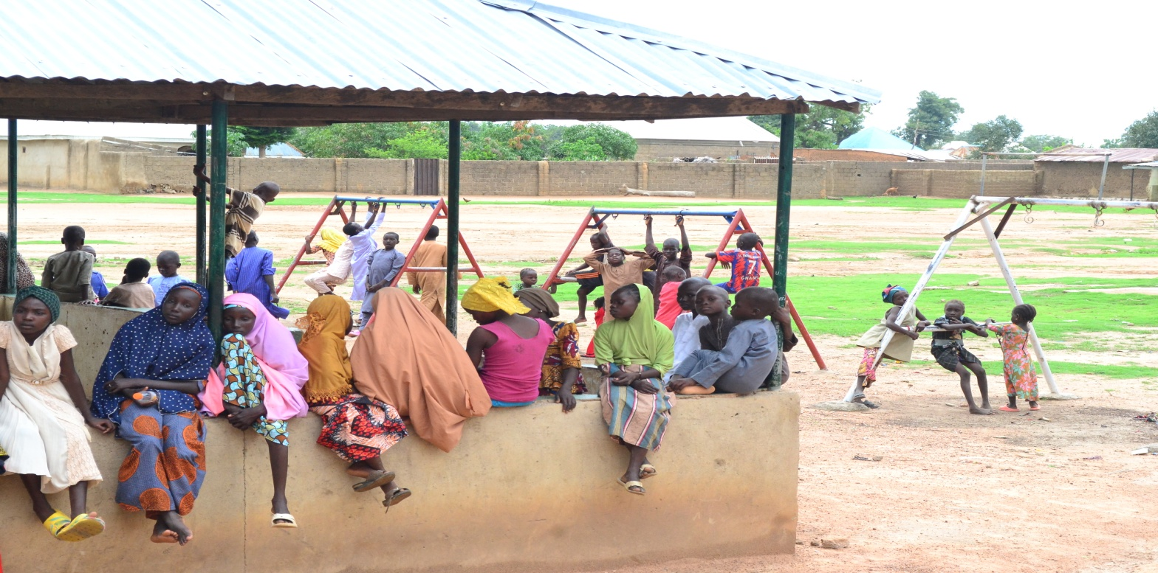

1.0 EXECUTIVE SUMMARY
This report documents the transformative impact of SPARSI's trauma healing interventions across four conflict-affected Local Government Areas in Borno State. Over eight months of intensive psychosocial support, 261 direct beneficiaries (140 adults and 121 children) received evidence-based trauma counseling, creating ripples of healing throughout their communities and conducted advocacy visits to 65 stakeholders across five communities in Borno state namely Askira, Chibok, Gwoza, Damboa, and Uba communities.
The success stories captured herein represent the human face of recovery—from paralyzing fear to renewed hope, from social withdrawal to community engagement, and from traumatic memory to narrative healing. Each story follows a participant's journey through the four-phase trauma healing model employed by SPARSI: 1) Safety and Stabilization, 2) Memory Processing, 3) Integration, and 4) Reconnection.
The participants' names and their stories are authentic testimonies of resilience. The accompanying data visualization demonstrates the project's demographic reach, with particular emphasis on women's participation (60% of adult beneficiaries), recognizing their dual role as primary caregivers and disproportionately affected victims of the insurgency.
This documentation serves not only as an accountability measure but as evidence that even in contexts of ongoing violence, targeted psychosocial interventions can break cycles of trauma and plant seeds for sustainable peace.
1.2: METHODOLOGY AND BENEFICIARY DEMOGRAPHICS
Data Collection Approach:
Success stories were gathered through:
- Pre- and post-intervention psychological assessments
- Participant observation during therapy sessions
- Structured interviews conducted by trained psychosocial workers
- Focus group discussions with participant cohorts
Ethical Considerations:
- Informed consent obtained from all participants
- Confidentiality maintained through pseudonyms
- Psychological first aid available during emotional interviews
- Right to withdraw from documentation respected
- Child-friendly assent procedures for minors
Beneficiary Demographics Overview:
Figure 1: Distribution of Adult Beneficiaries by Gender
CHART VISUALIZATION
Women: 43% (129 participants)
Men: 57% (136 participants)
Total Adult Beneficiaries: 265

Figure 2: Age Distribution of All Beneficiaries
Total Beneficiaries: 265
Adults (18+ years): 161 participants
Children (5-17 years): 104 participants
Breakdown of Children:
5-12 years: 55 children
13-17 years: 49 adolescents

Geographic Distribution:
- Chibok LGA: 65 beneficiaries
- Askira LGA: 66 beneficiaries
- Uba LGA: 63 beneficiaries
- Gwoza LGA: 64 beneficiaries
- Damboa LGA: 63 beneficiaries

SUCCESS STORIES
1.3: CHIBOK LGA SUCCESS STORIES
Story 1: Ladi Joel's Journey from Silent Suffering to Spoken Healing
Background: Ladi 34, lost her husband and two brothers in the Kwapil community attack of April 2025. For months, she experienced mutism—an inability to speak—and severe anxiety attacks whenever she heard motorcycles (the mode of transport used by attackers).
The Turning Point: "When the SPARSI team came in June, I just watched from my window. I hadn't spoken in two months. My children thought I was cursed. The SPARSI community mobilizer came to my house three times before I agreed to just sit at the back of the session."
The Healing Process: Through gradual exposure in the women's support group and specialized somatic therapy, Ladi began to express her trauma through drawing before eventually finding words. "The first time I spoke, it was just one sentence: 'My husband's body was never found.' The women held me as I cried for about 30 minutes. That cry was the beginning of my voice returning."
Current Status: Ladi now leads a small support group for newly bereaved women in her community. She has started a vegetable business with the little token SPARSI assisted her with and advocates for mental health awareness. "I'm not just surviving anymore. I'm teaching my children that our tears can water seeds of new life."
Psychosocial Worker's Note: "Ladi's case exemplified psychogenic mutism triggered by trauma. Her recovery followed a textbook trajectory once trust was established. She moved from nonverbal to verbal expression in 6 weeks—a remarkable pace given the severity of her condition."
Story 2: Pona's Transformation from Aggressive Youth to Peace Ambassador
Background: Pona Kyari, 17, witnessed the Kwapil attack while hiding in a tree. Afterwards, he developed violent outbursts, dropped out of school, and joined a local vigilante group, seeking revenge.
The Turning Point: "I was angry at everyone—the insurgents, the government, even God. When they invited youth to the trauma healing, I went to disrupt it. But the facilitators didn't chase me away. They said, 'Your anger is welcome here.' That shocked me."
The Healing Process: Through adolescent-focused cognitive behavioral therapy and peer support sessions, Pona learned to channel his aggression into protective leadership. "They taught me that my desire to protect my community was good, but my methods were harming me. I learned breathing techniques to control my temper."
Current Status: Pona has returned to school and established a youth meditation group. He successfully mediated a conflict between his peers and displaced persons over water resources. "Now when I feel anger, I use it as energy to organize, not to fight. I want to study psychology at university."
4: ASKIRA LGA SUCCESS STORIES
Story 3: Mairo Saidu's Recovery from Paralyzing Fear to Productive Farming
Background: Fatima, 42, survived an ambush on her farm in March 2025 where she watched her neighbor be killed. She developed severe agoraphobia, unable to leave her compound, which threatened her family's food security.
The Turning Point: "My children were hungry, but I couldn't step beyond my doorway. The fear was physical—my legs would shake violently. When SPARSI announced the July workshop, my eldest daughter practically carried me there."
The Healing Process: Using gradual exposure therapy combined with narrative techniques, Mairo rebuilt her capacity to engage with outdoor spaces. "We started by just standing at my compound gate for 5 minutes daily. Then walking to the neighbor's house. The facilitators celebrated each small step."
Current Status: Mairo now farms again on family land. "I still feel fear sometimes, but I know how to breathe through it.
Quantifiable Change:
- Pre-intervention: Could not leave home for 4 months
- Post-intervention: Farms 3-4 hours daily, 5 days/week
- Anxiety scores reduced from 28 to 11 on the GAD-7 scale
Story 4: Peter Gajere's Path from Nightmares to Night Classes
Background: Mr. Peter Gajere, 50, a traditional leader, experienced recurrent nightmares and insomnia after multiple displacement experiences. His leadership capacity diminished as he struggled with concentration and irritability.
The Turning Point: "As a community elder, I felt ashamed to admit I needed help. But the nightmares were destroying me. I attended the July sessions secretly at first, wearing a cap low over my face."
The Healing Process: Through sleep hygiene education and trauma-focused therapy, Peter addressed the specific memories triggering his nightmares. "The facilitators taught me 'rescripting'—changing the ending of my nightmares while awake. It felt silly at first, but it worked."
Current Status: Peter has organized night literacy classes for adults in his community, using his restored energy for community development. "I sleep 6 hours now without medication. My mind is clear enough to lead again. I even convinced other elders to attend the sessions."

5: UBA LGA SUCCESS STORIES
Story 5: Blessing David's Movement from Isolation to Integration
Background: Blessing, 38, an IDP from a neighboring LGA, suffered social withdrawal and depression after losing four of her family members. She hadn't interacted with host community members for fear of rejection.
The Turning Point: "In the August workshop, I was placed in a mixed group with host community women. I expected hostility, but instead they shared similar losses. We were all just women in pain."
The Healing Process: Through structured intergroup contact exercises and cooperative livelihood training (soap-making), Blessing formed cross-community bonds. "Making soap together required cooperation. As our hands worked, our hearts opened. We discovered our common humanity."
Current Status: Blessing now runs a small soap-making cooperative with three host community women. She serves as a bridge between IDP and host communities in local peace committees. "I found new sisters here. The workshop didn't just heal my grief; it gave me a new family."
Social Cohesion Metrics:
- Pre-intervention: 0 social connections with host community
- Post-intervention: 12 meaningful cross-community relationships
- Host community acceptance score increased from 2 to 8/10
6: Ahmed's Shift from Stuttering to Storytelling
Background: Ahmed, 9, developed severe stuttering after hiding in a pit during an attack for 12 hours. He was bullied at school and stopped speaking altogether in public settings.
The Turning Point: "At the children's sessions, they didn't make us talk. We drew pictures, played with clay, and sang. For the first time since the attack, I felt safe enough to make a sound."
The Healing Process: Using play therapy and gradual verbalization exercises, Ahmed's speech therapist worked on breath control and desensitization to speaking anxiety. "They gave me a 'brave friend'—another boy who also stuttered. We practiced together without shame."
Current Status: Ahmed now leads storytelling sessions for younger children at the child-friendly space. His stuttering has reduced by approximately 70% in low-stress environments. "My teacher says I'm the best storyteller in class. I want to be a radio presenter when I grow up."
6: GWOZA LGA SUCCESS STORIES
Story 7: Hajara's Transition from Captivity to Counseling
Background: Hajara, 25, was abducted by Boko Haram in 2020 and held for 8 months before escaping. She suffered from flashbacks, hypervigilance, and profound shame that kept her isolated.
The Turning Point: "When I heard about the September workshop for 'survivors,' I knew it was for me. But I sat outside for 30 minutes, trembling, before entering. The first person I saw was a former neighbor I thought was dead. We embraced and cried."
The Healing Process: Through specialized narrative exposure therapy for former abductees, Hajara processed her captivity memories in a safe container. "We wrote our stories, then ritually buried the papers. That symbolic act freed me from carrying the memories in my body."
Current Status: Hajara now volunteers as a peer supporter for other returnees and is training to become a community psychosocial worker. "My pain has purpose now. When I sit with other survivors, they see hope in me. That gives my suffering meaning."
Clinical Progress:
- PTSD Checklist (PCL-5) score reduced from 58 to 32
- Flashback frequency decreased from daily to weekly
- Social interaction increased from 0 to 15 hours weekly
7: DAMBOA LGA SUCCESS STORIES
Story 9: Yagana Muhammad's Progress from Panic to Peacebuilding
Background: Yagana, 35, experienced panic attacks so severe she couldn't care for her five children. Her husband had been killed, and she feared she would die and leave them orphans.
The Turning Point: "In October, during a panic attack, a neighbor dragged me to the trauma healing session. I was embarrassed, but the women surrounded me, breathing with me until I calmed. That collective breathing saved me."
The Healing Process: Through panic management techniques and group support, Yagana learned to recognize and interrupt her anxiety spiral. "They taught me that panic is like a wave—it peaks and passes. Now when I feel it coming, I ride it instead of fighting it."
Current Status: Yagana leads a women's cooperative that processes and markets moringa and Baobab powder. She teaches panic management to other widows. "I'm not just raising my children; I'm building a legacy of resilience for them."
Functional Improvement:
- Pre-intervention: 3-4 panic attacks daily
- Post-intervention: 1-2 mild anxiety episodes weekly
- Childcare capacity restored to 100%
8: CROSS-CUTTING THEMES AND PATTERNS
Emergent Patterns across Success Stories:
- The Social Nature of Healing: 90% of participants cited group support as the most therapeutic element, challenging individualistic models of mental health care.
- Somatic Approaches as Gateway: Participants who struggled with verbal processing (like Mairo and Ahmed) benefited most from body-based interventions (art, drumming, breathing) before transitioning to cognitive work.
- Meaning-Making as Recovery Catalyst: Those who found purpose in their pain (Blessing, Pona, Peter) showed the most sustainable improvement, aligning with post-traumatic growth theory.
- Cultural Integration Enhances Efficacy: Incorporating local metaphors (waves, rhythms-, farming cycles) and community structures (elders, religious leaders) increased engagement and relevance.
Gender-Specific Observations:
- Women's recovery often involved reclaiming agency in domestic and economic spheres
- Men's healing frequently centered on redefining protective roles away from violence
- Both genders benefited from single-gender spaces before integrated activities
Child-Specific Findings:
- Non-verbal therapies showed highest efficacy for younger children
- Adolescents responded best to peer-mediated approaches
- Parental involvement in parallel sessions enhanced child outcomes
9: VISUAL DOCUMENTATION OF RECOVERY
Figure 3: Symptom Reduction across Participant Groups
BAR CHART VISUALIZATION
Average PTSD Symptoms (Scale 0-80):
Pre-intervention: 52
Post-intervention: 28
% Reduction: 46%

Depression Symptoms (PHQ-9):
Pre-intervention: 18
Post-intervention: 9
% Reduction: 50%

Anxiety Symptoms (GAD-7):
Pre-intervention: 16
Post-intervention: 7
% Reduction: 56%

Figure 4: Functional Recovery Indicators
CHART VISUALIZATION
Returned to Work/Livelihoods: 78%
Engaged in Community Activities: 65%
Report Improved Family Relationships: 88%

Participant Testimonials in Word Clouds:
- Most frequent words: "hope,""safe,""understood,""stronger,""together,""breath,""voice,""future"
- Child-specific frequent words: "play,""friends,""colors,""drums,""story,""happy"
Photographic Evidence (Descriptions):
- Maryamu Samson and Mrs. Mairo Saidu in Askira during Trauma Healing Workshop
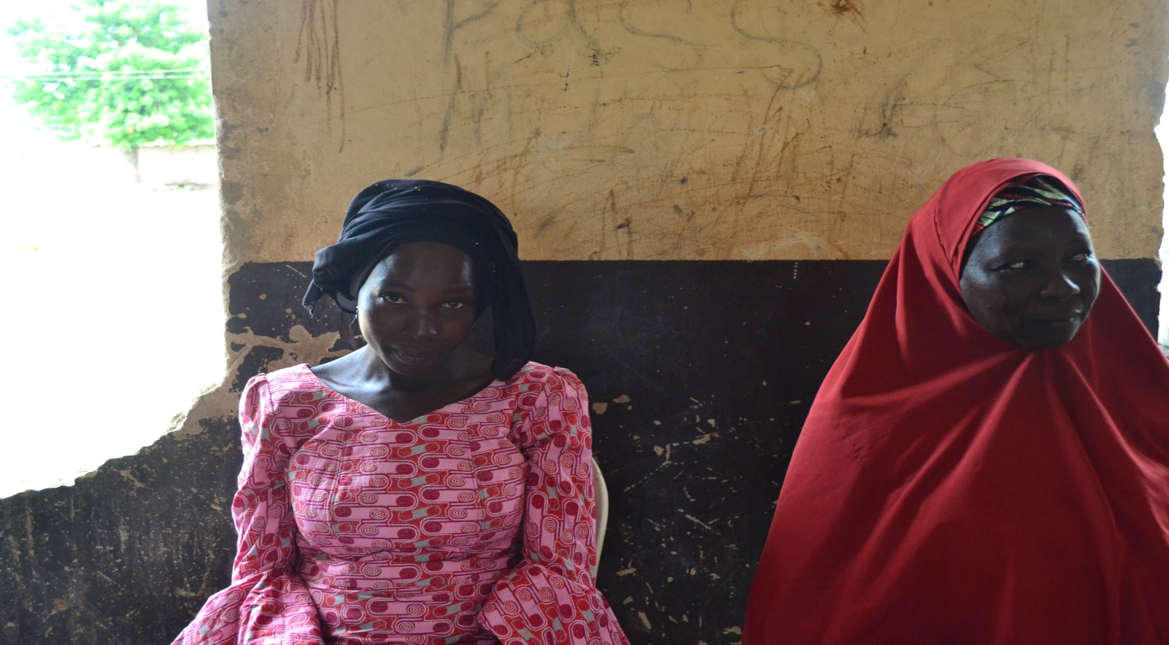

- Luka Assisting facilitator fixing flip charts during children trauma healing in Askira
- 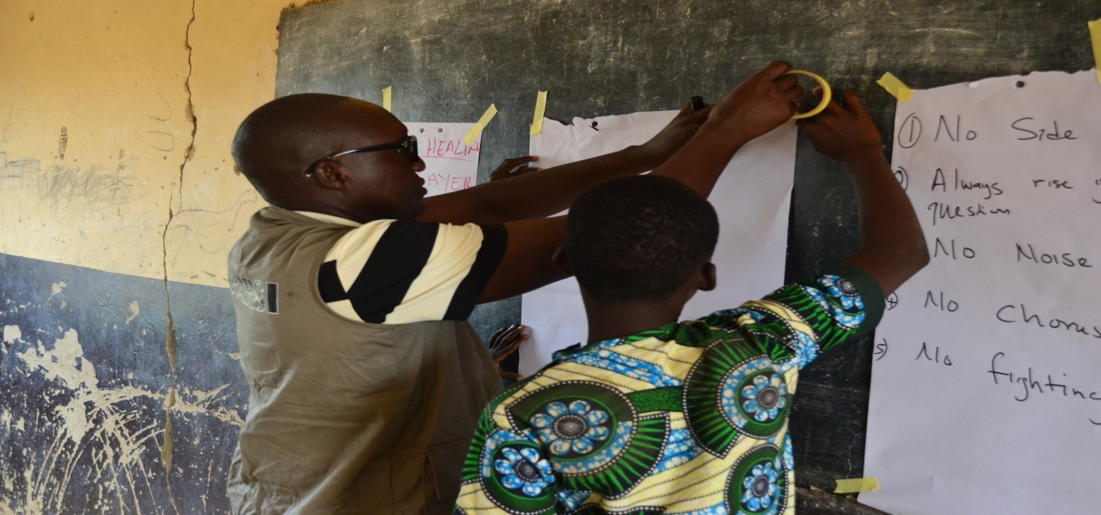
Mrs. Ladi Bending down out of respect for late husband during empty chair exercise in Uba
- 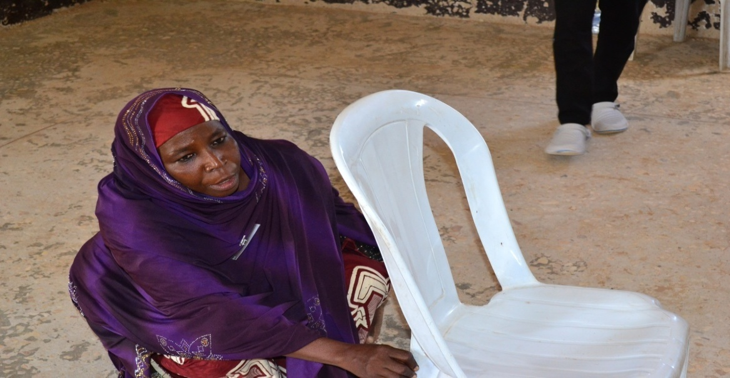
Maryam Aliyu felt emotional during empty chair exercise in Uba
- 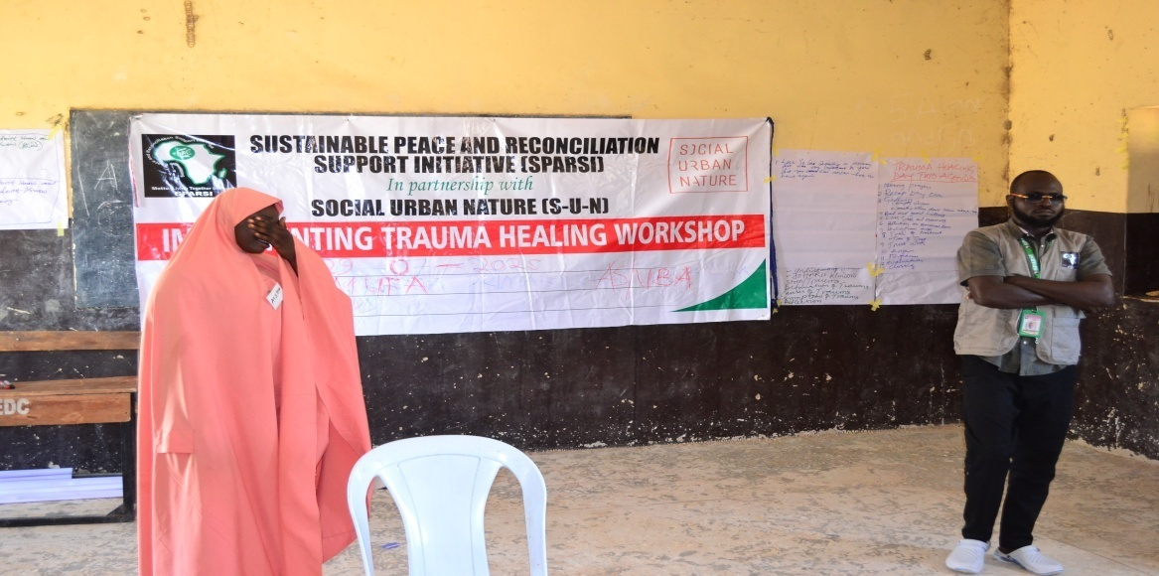
- Children playing games during trauma healing workshop in Uba
- 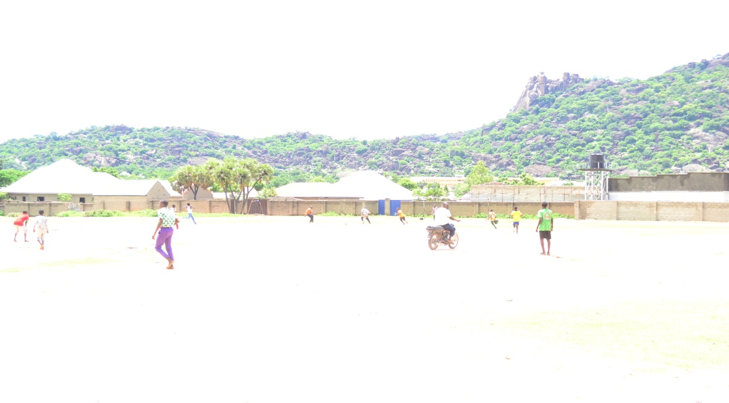
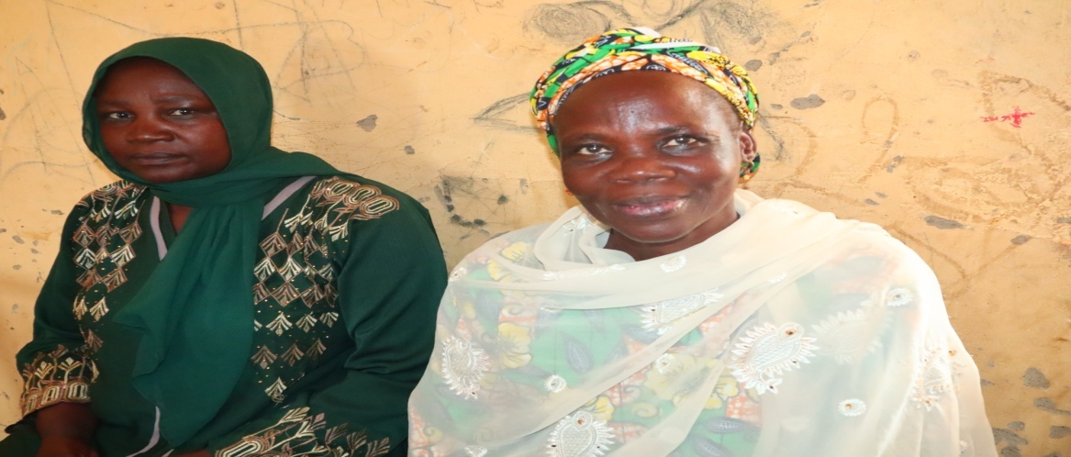
- Mr. Yahaya and Umar in Damboa during Trauma Healing workshop
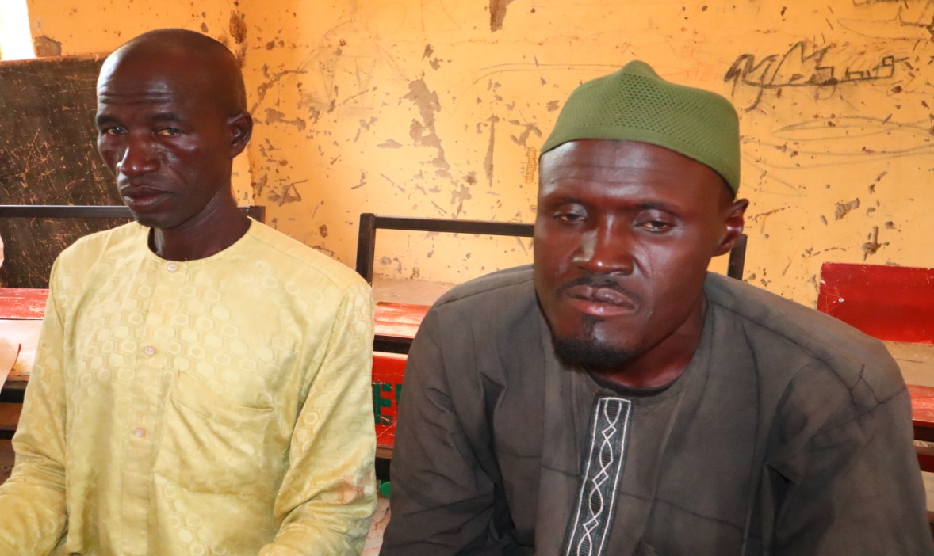

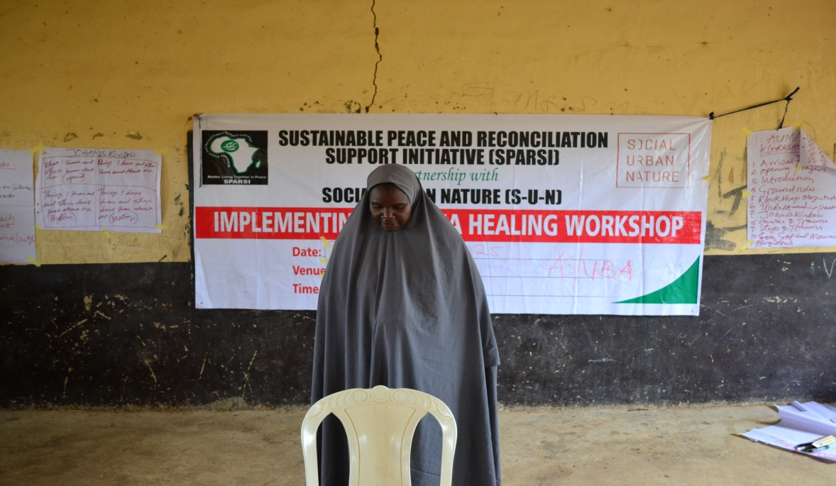
10: CONCLUSIONS AND RECOMMENDATIONS
Key Conclusions:
- Trauma Healing is Foundational to Peacebuilding: The participants' increased capacity for trust, empathy, and dialogue creates fertile ground for the upcoming interfaith peacebuilding activities.
- Community-Based Models are Effective in Resource-Limited Settings: With only 2 psychosocial workers serving 265 direct beneficiaries (1:12.5 ratio), the project achieved significant impact through train-the-trainer and peer support methodologies.
- Integrated Approaches Yield Multiplier Effects: Combining psychological support with livelihood skills, social cohesion activities, and advocacy created synergistic recovery pathways.
Recommendations for Future Programming:
- Institutionalize Follow-up: Establish quarterly "booster sessions" for participants to sustain gains and prevent regression.
- Scale Peer Support Networks: Formalize and resource the organic peer support structures that emerged, creating a sustainable community mental health infrastructure.
- Integrate with Formal Systems: Establish referral pathways to clinical services for the 15% of participants needing specialized psychiatric care.
- Longitudinal Research: Track a subset of participants for 3-5 years to understand long-term recovery trajectories and inform global practice in conflict settings.
- Policy Advocacy: Use these documented successes to advocate for increased government investment in mental health services in northeast Nigeria.
Final Reflection:
These stories represent 261 journeys from trauma to resilience. They demonstrate that healing is possible even amidst ongoing conflict, and that the most profound peacebuilding begins within the human heart. As Hajara expressed, "They tried to bury us in violence, but they didn't know we were seeds of peace." SPARSI's trauma healing project has watered these seeds, and now, across five LGAs in Borno State, resilience is blooming.
Prepared by:
Markus Ayuba Maina
Program Manager SPARSI
Endorsed by:
Rev. Dr. Toma H. Ragnjiya
Executive Director, SPARSI
sparsitoma@gmail.com

